SQL QUERIES

BASIC TO INTERMEDIATE

1. List all customers and the total number of orders they have placed.
Show only customers with more than 5 orders. Sort by total orders
descending.

select o.customerid, count(*) as total_orders from orders o
join customers c on c.customerid = o.customerid
group by o.customerid
having count(*) > 5
order by count(*) desc;

output:

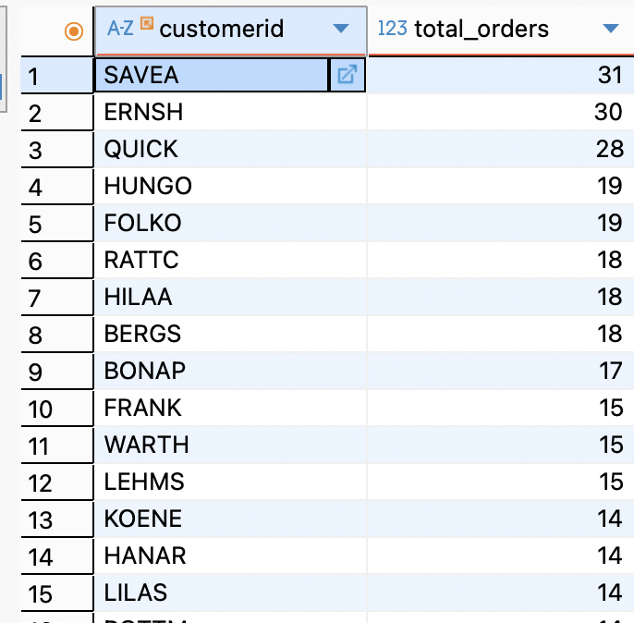

2. Retrieve the total sales amount per customer by joining customers, orders,
and order_details.
Show only customers whose total sales exceed 10,000. Sort by total sales
descending.

select o.customerid, round(sum(unitprice * quantity * (1-discount)):: numeric, 2) as total_sales from order_details od
join orders o on o.orderid = od.orderid
join customers c on c.customerid = o.customerid
group by o.customerid
having round(sum(unitprice * quantity * (1-discount))::numeric, 2) > 10000
order by sum(unitprice * quantity * (1-discount)) desc;

output:

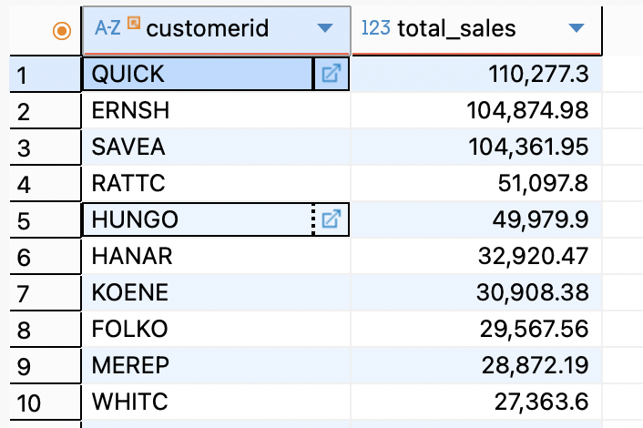

3. Get the number of products per category.
Show only categories having more than 10 products. Sort by product count
descending.

select p.categoryid, c.categoryname, count(*) as total_products from products p
join categories c on c.categoryid = p.categoryid
group by p.categoryid, c.categoryname
having count(*) > 10
order by count(*) desc;

output:

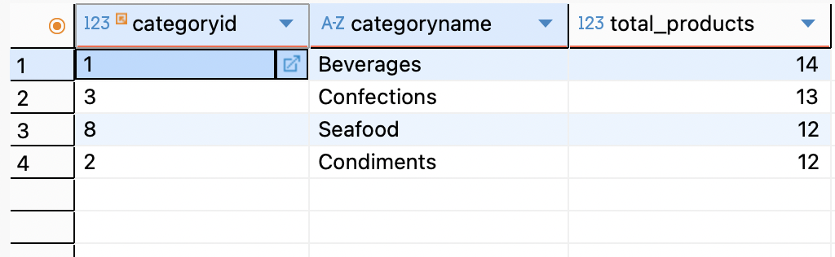

4. Display the total quantity sold per product.
Include only products where total quantity sold is greater than 100. Sort by
quantity descending.

select od.productid, p.productname, sum(quantity) as total_quantity from order_details od
join products p on p.productid = od.productid
group by od.productid, p.productname
having sum(quantity) > 100
order by sum(quantity) desc;

output:

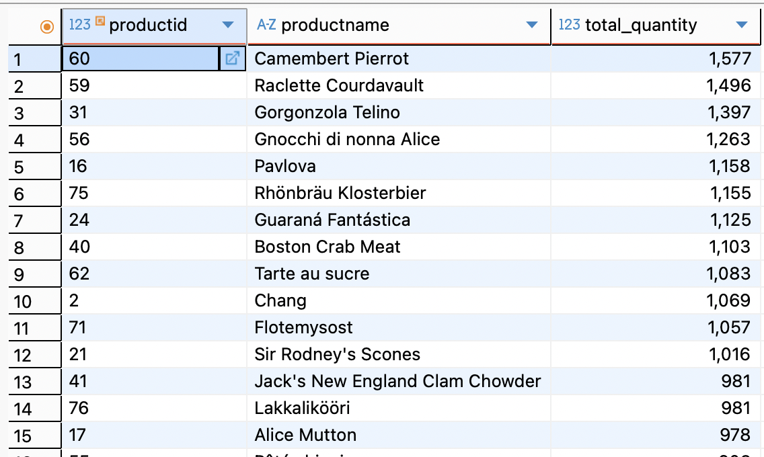

5. Find the total number of orders handled by each employee.
Show only employees who handled more than 20 orders. Sort by order count
descending.

select o.employeeid, concat(e.firstname, ' ', e.lastname) as employee_name, count(*) as total_orders from orders o
join employees e on e.employeeid = o.employeeid
group by o.employeeid, concat(e.firstname, ' ', e.lastname)
having count(*) > 20
order by count(*);

output:

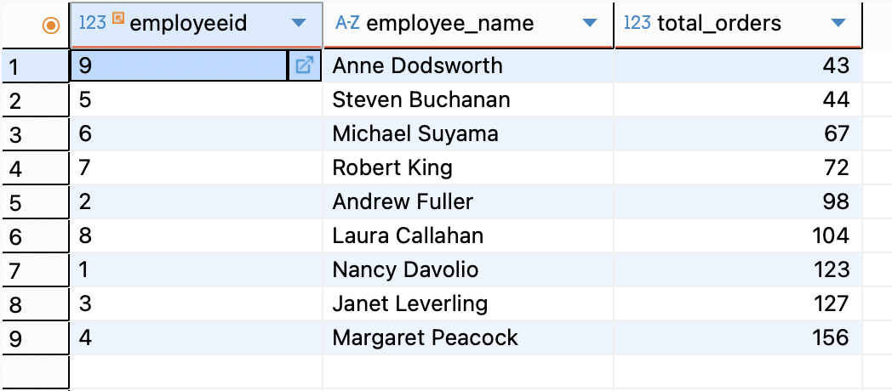

INTERMEDIATE:

6. Retrieve the total sales per category by joining categories, products, and
order_details.
Show only categories with total sales above 50,000. Sort by total sales
descending.

select p.categoryid, c.categoryname, round(sum(od.unitprice * od.quantity * (1-od.discount))::numeric, 2) as total_sales from order_details od
join products p on p.productid = od.productid
join categories c on c.categoryid = p.categoryid
group by p.categoryid, c.categoryname
having round(sum(od.unitprice * od.quantity * (1-od.discount))::numeric, 2) > 50000
order by round(sum(od.unitprice * od.quantity * (1-od.discount))::numeric, 2);

Output:

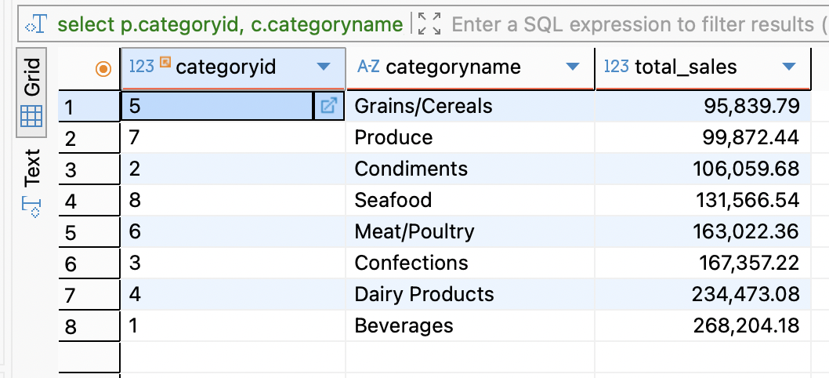

7. List suppliers and the number of products they supply.
Show only suppliers who supply more than 5 products. Sort by product count
descending.

select p.supplierid, s.contactname as suppliername, count(*) as total_products_supplied from products p
join suppliers s on s.supplierid = p.supplierid
group by p.supplierid, s.contactname
having count(*) > 5
order by count(*);

output:

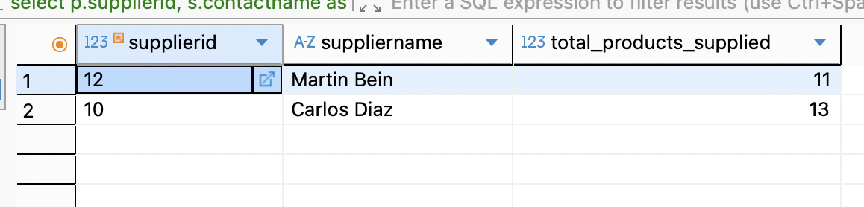

8. Get the average unit price per category.
Show only categories where the average price is above 30. Sort by average
price descending.

select p.categoryid, c.categoryname, round(avg(p.unitprice)::numeric, 2) as avg_unitprice from products p
join categories c on c.categoryid = p.categoryid
group by p.categoryid, c.categoryname
having round(avg(p.unitprice)::numeric, 2) > 30
order by round(avg(p.unitprice)::numeric, 2);

output:

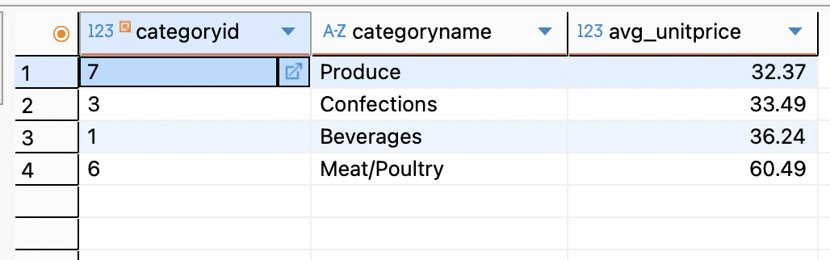

9. Display the total revenue generated per employee (orders + order_details).
Show only employees generating more than 20,000 in revenue. Sort by
revenue descending.

select o.employeeid, concat(e.firstname, ' ', e.lastname) as employee_name, round(sum(od.unitprice * od.quantity * (1-discount))::numeric, 2) as total_revenue_by_employee from order_details od
join orders o on o.orderid = od.orderid
join employees e on e.employeeid = o.employeeid
group by o.employeeid, concat(e.firstname, ' ', e.lastname)
having round(sum(od.unitprice * od.quantity * (1-discount))::numeric, 2) > 20000
order by round(sum(od.unitprice * od.quantity * (1-discount))::numeric, 2) desc;

output:

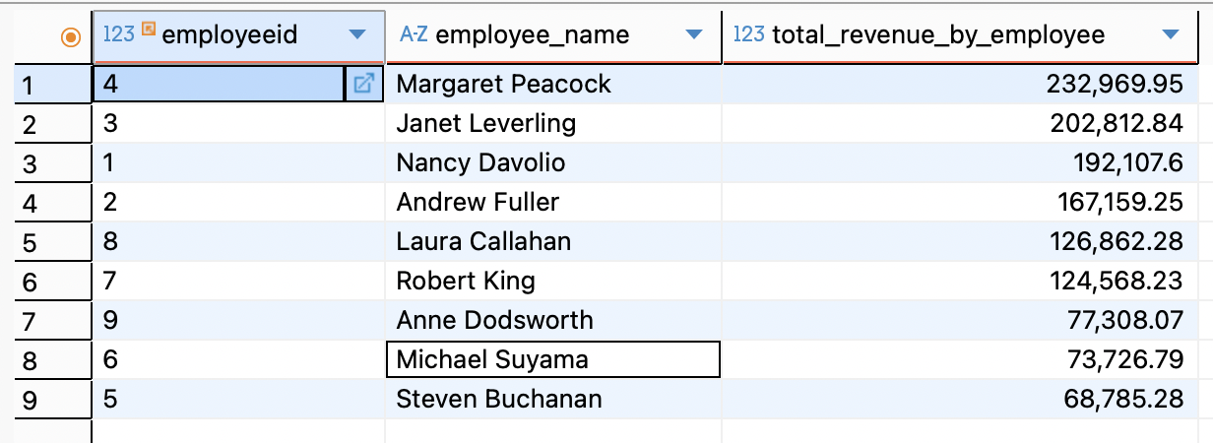

10. Retrieve the number of orders shipped to each country.
Show only countries with more than 10 orders. Sort by order count
descending.

select shipcountry, count(*) as total_orders_shipped from orders
group by shipcountry
having count(*) > 10
order by count(*);

output:

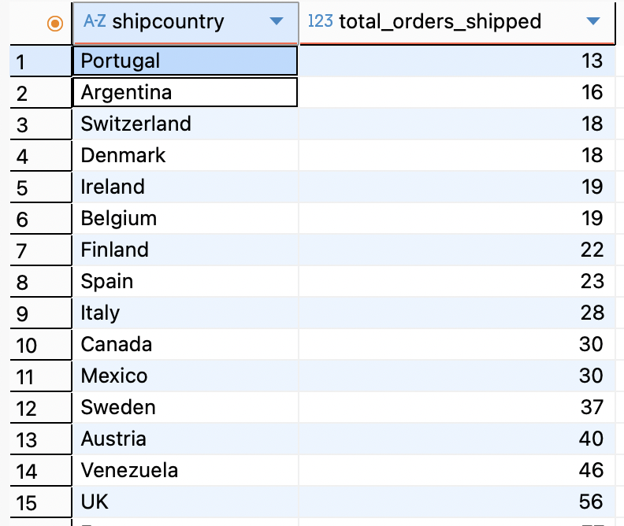

ADVANCED:

11. Find customers and the average order value (orders + order_details).
Show only customers with average order value greater than 500. Sort by
average descending.

select
order_totals.customerid,
round(avg(order_total)::numeric, 2) as avg_order_value
from (
select
o.orderid,
o.customerid,
sum(od.unitprice * od.quantity * (1 - od.discount)) as order_total
from orders o
join order_details od on o.orderid = od.orderid
group by o.orderid, o.customerid
) as order_totals
join customers c on c.customerid = order_totals.customerid
group by order_totals.customerid
having round(avg(order_total)::numeric, 2) > 500
order by avg_order_value desc;

output:

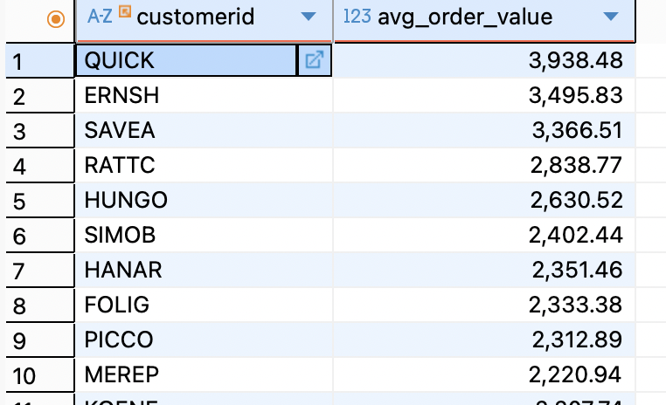

12. Get the top-selling products per category (by total quantity sold).
Show only products with total quantity sold above 200. Sort within category by
quantity descending.

select
p.categoryid,
c.categoryname,
p.productid,
p.productname,
sum(od.quantity) as total_quantity
from order_details od
join products p on p.productid = od.productid
join categories c on c.categoryid = p.categoryid
group by p.categoryid, c.categoryname, p.productid, p.productname
having sum(od.quantity) > 200
order by p.categoryid, total_quantity desc;

output:

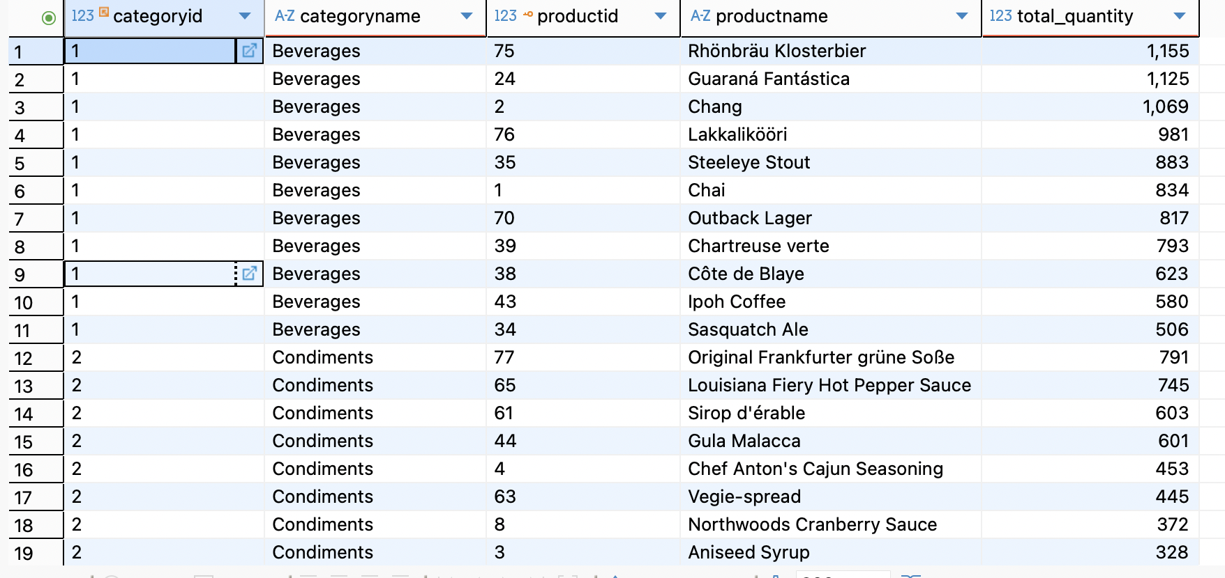

13. Retrieve the total discount given per product (order_details).
Show only products where total discount exceeds 1,000. Sort by discount
descending.

select productid, round(sum(unitprice * quantity * discount)::numeric, 2) as total_discount_amount from order_details
group by productid
having round(sum(unitprice * quantity * discount)::numeric, 2) > 1000
order by total_discount_amount;

output:

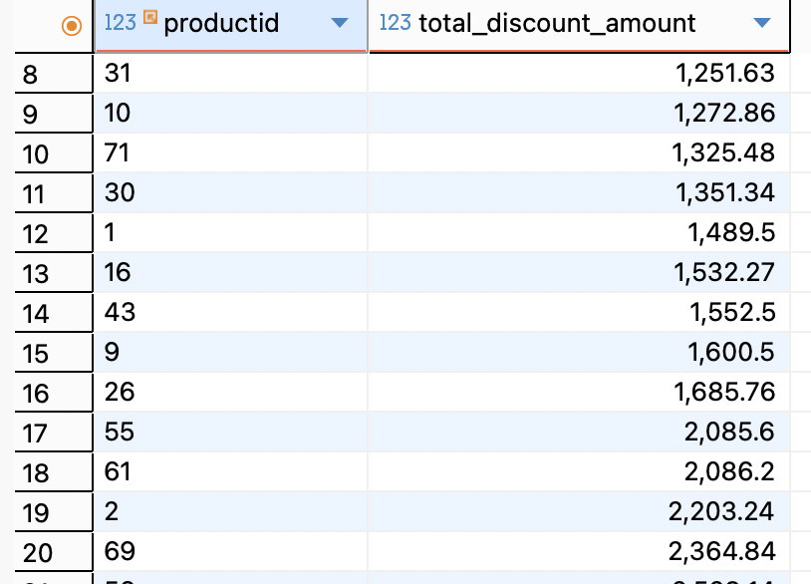

14. List employees and the number of unique customers they handled.
Show only employees who handled more than 15 unique customers. Sort by
count descending.

select e.employeeid, concat(e.firstname, ' ', e.lastname) as employeename,
count(distinct o.customerid) as unique_customers_handled
from orders o
join employees e on e.employeeid = o.employeeid
group by e.employeeid, e.firstname , e.lastname
having count(distinct o.customerid ) > 15
order by unique_customers_handled desc

output:

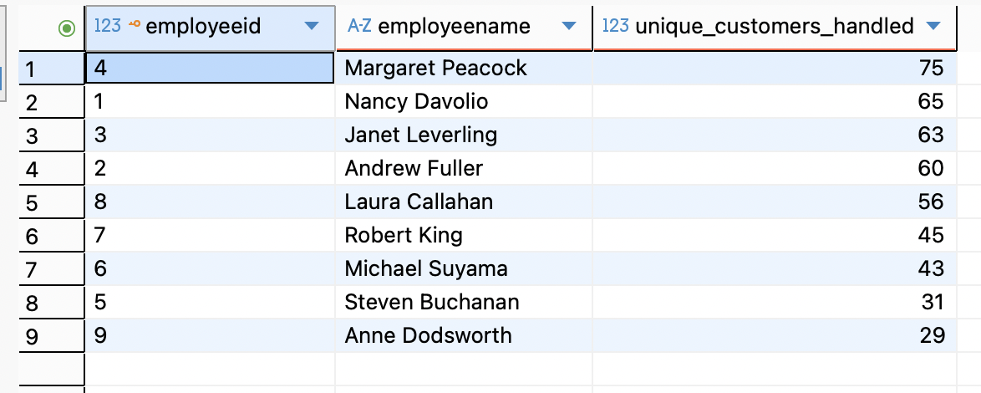

15. Find the monthly total sales (year + month) using orders and order_details.
Show only months where total sales exceed 30,000. Sort by year and month
ascending.

select extract(year from o.orderdate) as year,
extract(month from o.orderdate) as month,
round(sum(od.unitprice * od.quantity * (1-discount))::numeric, 2) as total_sales
from orders o join order_details od
on o.orderid = od.orderid
group by extract(year from o.orderdate),
extract(month from o.orderdate)
having round(sum(od.unitprice * od.quantity * (1-discount))::numeric, 2) > 30000
order by year, month;

output:

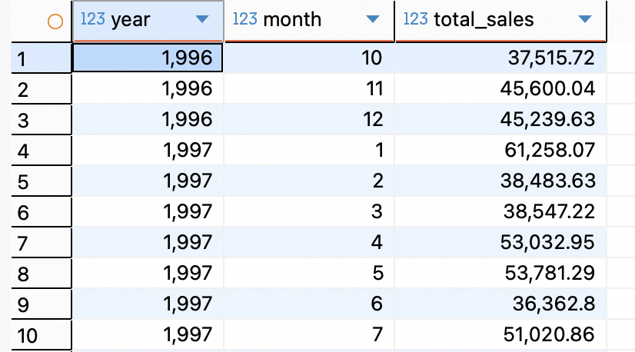

STORED PROCEDURES:

1. Create a stored procedure to insert a new customer.

create or replace procedure insert_customer(
customerid varchar(5),
companyname varchar(40),
contactname varchar(30)
)
language plpgsql
as $$
begin
if customerid is null or companyname is null or contactname is null then
raise exception 'customerid, companyname, contactname is required';
rollback;
end if;

insert into customers(customerid, companyname, contactname) values
(customerid, companyname, contactname);
commit;

raise notice 'customer % inserted successfully', customerid;

end;
$$;

call insert_customer('AS001', 'Alia', 'ABC Corp');
call insert_customer('AS002', 'Blia', 'ABC Corp');

select * from customers;

output:
customer AS001 inserted successfully
customer AS002 inserted successfully

Table: customers

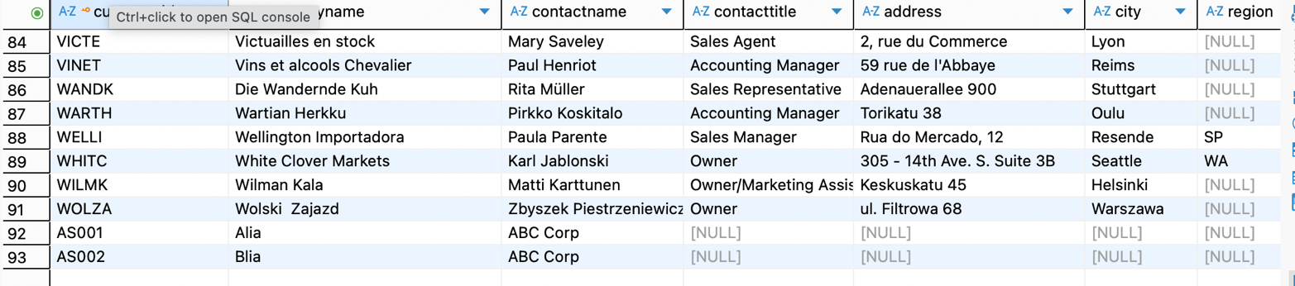

2. Create a stored procedure to place a new order for an existing customer with one product. Insert into orders and order_details in a single transaction.
create or replace procedure place_new_order( p_customerid varchar(50), p_productid int, p_quantity int
)
language plpgsql
as $$
declare
v_orderid int;
v_unitprice dec;
v_discount float := 0;
begin
if not exists (select 1 from customers where customerid = p_customerid) then
raise exception 'customer with id % does not exist', p_customerid;
rollback;
end if;
select unitprice into v_unitprice from products
where productid = p_productid;
if not found then
raise exception 'product with id % does not exist', p_productid;
rollback;
end if;
if p_quantity <= 0 then
raise exception 'quantity must be greater than 0';
rollback;
end if;
insert into orders(
customerid,
orderdate,
requireddate,
shipcountry
) values (
p_customerid,
current_date,
current_date + interval '7 days',
(select country from customers where customerid = p_customerid)
)
returning orderid into v_orderid;
insert into order_details(
orderid,
productid,
unitprice,
quantity,
discount
) values (
v_orderid,
p_productid,
v_unitprice,
p_quantity,
v_discount
);

raise notice 'order placed successfully! order id: %, product: %, quantity: %, total = %',
v_orderid, p_productid, p_quantity, (v_unitprice * p_quantity);
end;
$$;

call place_new_order('anatr', 2, 5);

output:

Order placed successfully! Order ID: 11086, Product: 2, Quantity: 5, Total = 95.0000

Table: orders

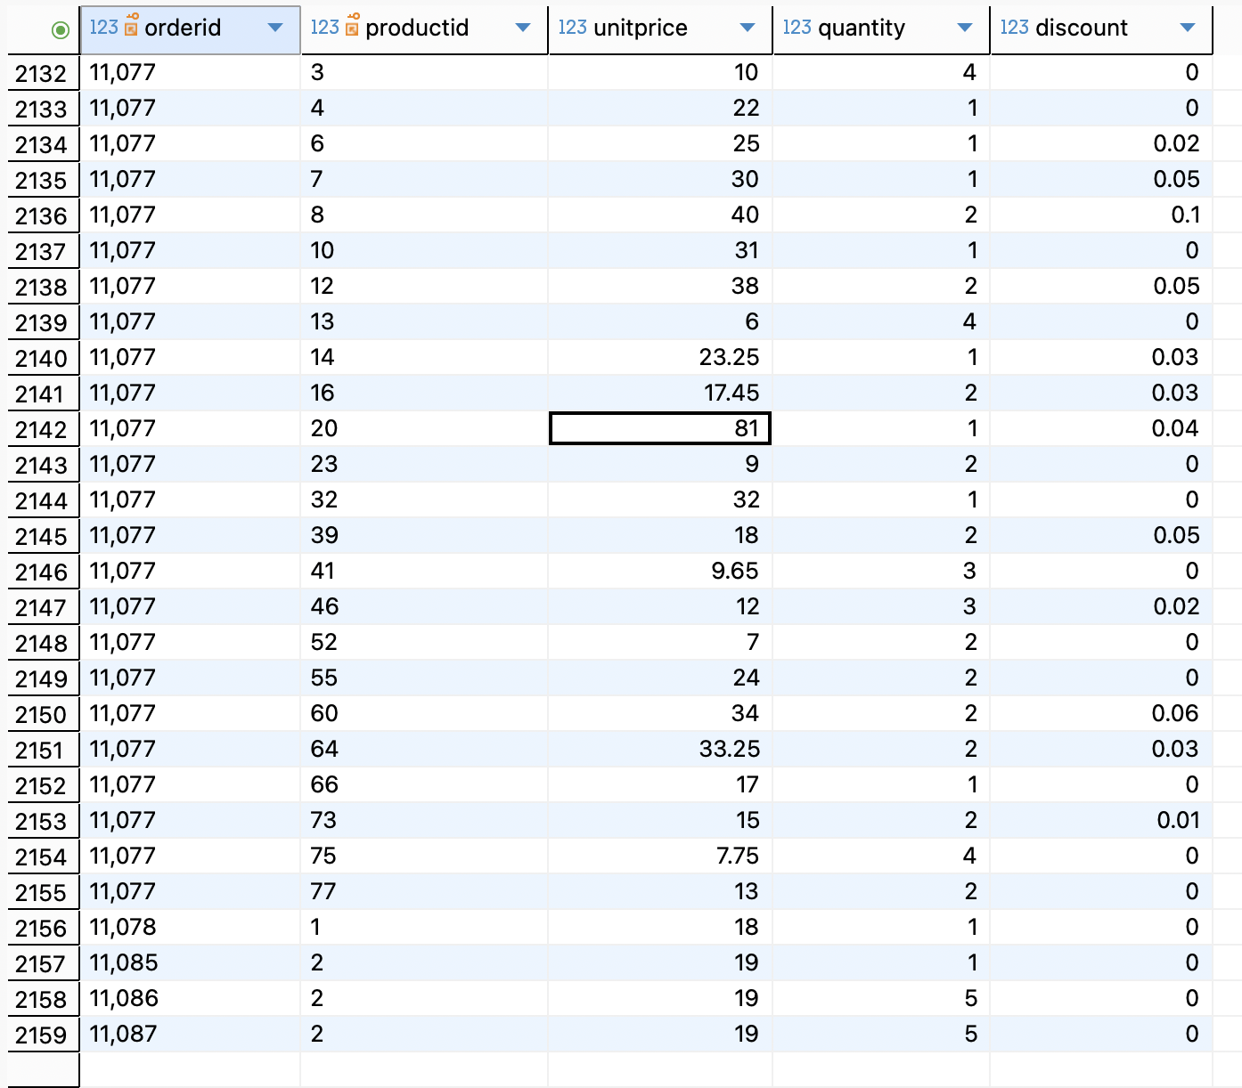

3. Create a stored procedure to update product stock after an order is placed. If stock is not enough, rollback the transaction.

create or replace procedure update_stock(
p_order_id int
)
language plpgsql
as $$
declare
v_product record;
begin
for v_product in
select productid, quantity from order_details where orderid = p_order_id
loop
update products
set unitsinstock = unitsinstock - v_product.quantity
where productid = v_product.productid
and unitsinstock >= v_product.quantity;

if not found then
raise exception 'insufficient stock for product id: %', v_product.productid;
rollback;
end if;
end loop;

commit;
raise notice 'stock updated for order %', p_order_id;
end;
$$;

Table: products(before order placed and stock updation -> for productid=2, unitsinstock=11

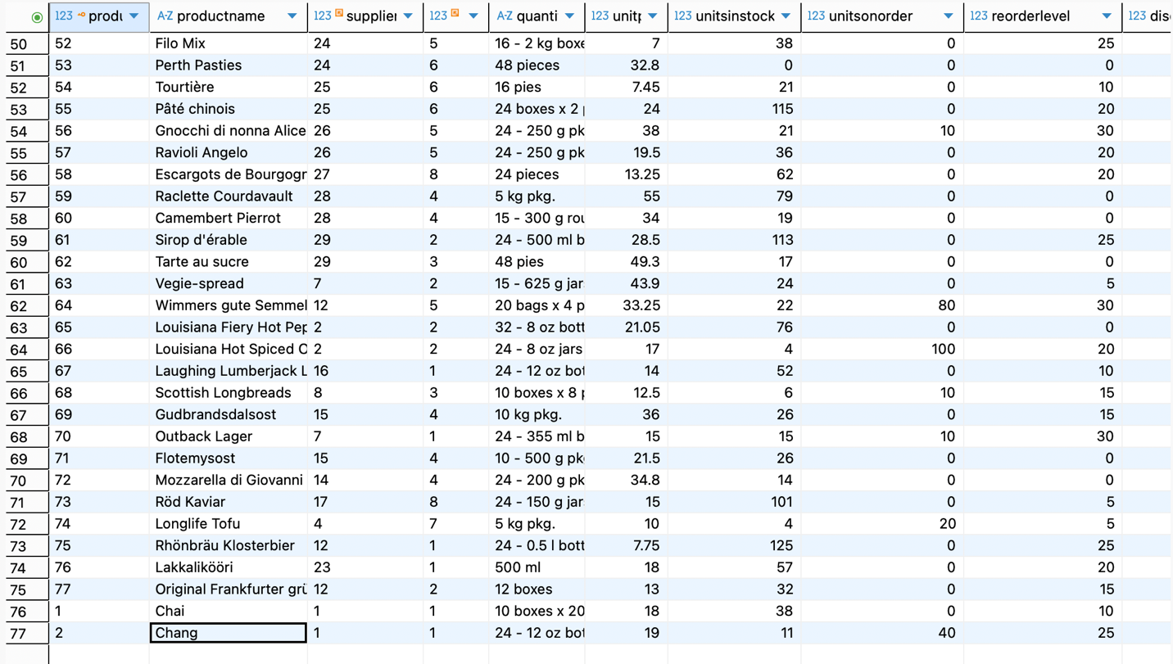

call update_stock(11087);

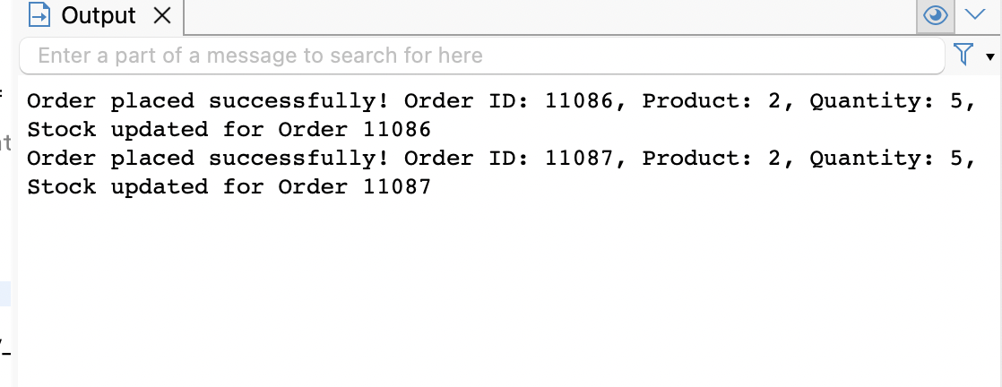

Table: orders

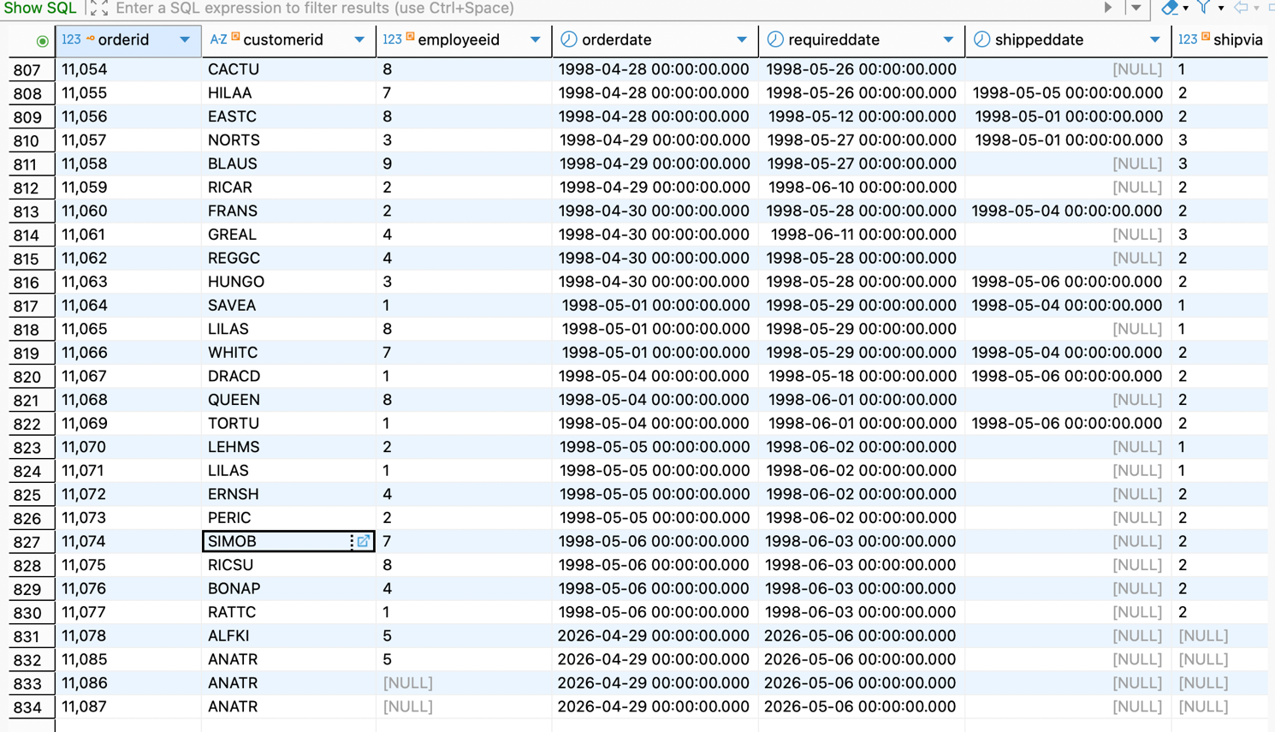

Table: order_details



Table: products(after order placed and stock updation -> for productid=2, unitsinstock=11-5=6

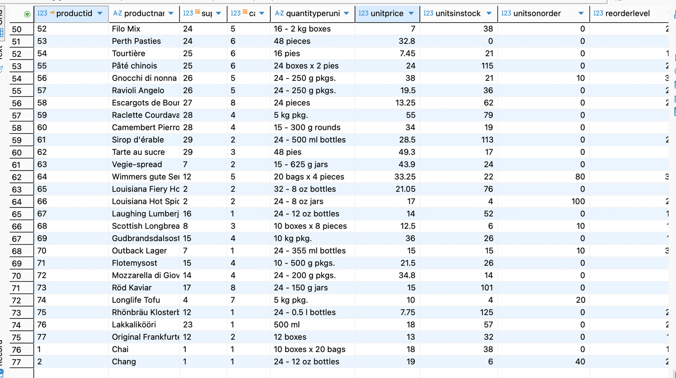

4. Create a stored procedure to cancel an order. Delete records from order_details first, then from orders, using a transaction.

create or replace procedure cancel_order(
p_orderid int
)
language plpgsql
as $$
begin
if not exists (select 1 from orders where orderid=p_orderid)
then
raise exception 'order % does not exist', p_orderid;
rollback;
end if;
delete from order_details where orderid = p_orderid;
delete from orders where orderid = p_orderid;
commit;
raise notice 'order % cancelled successfully', p_orderid;
end;
$$;

call cancel_order(11087);

output:
order 11087 cancelled successfully

table: order (before cancelling order=11087)
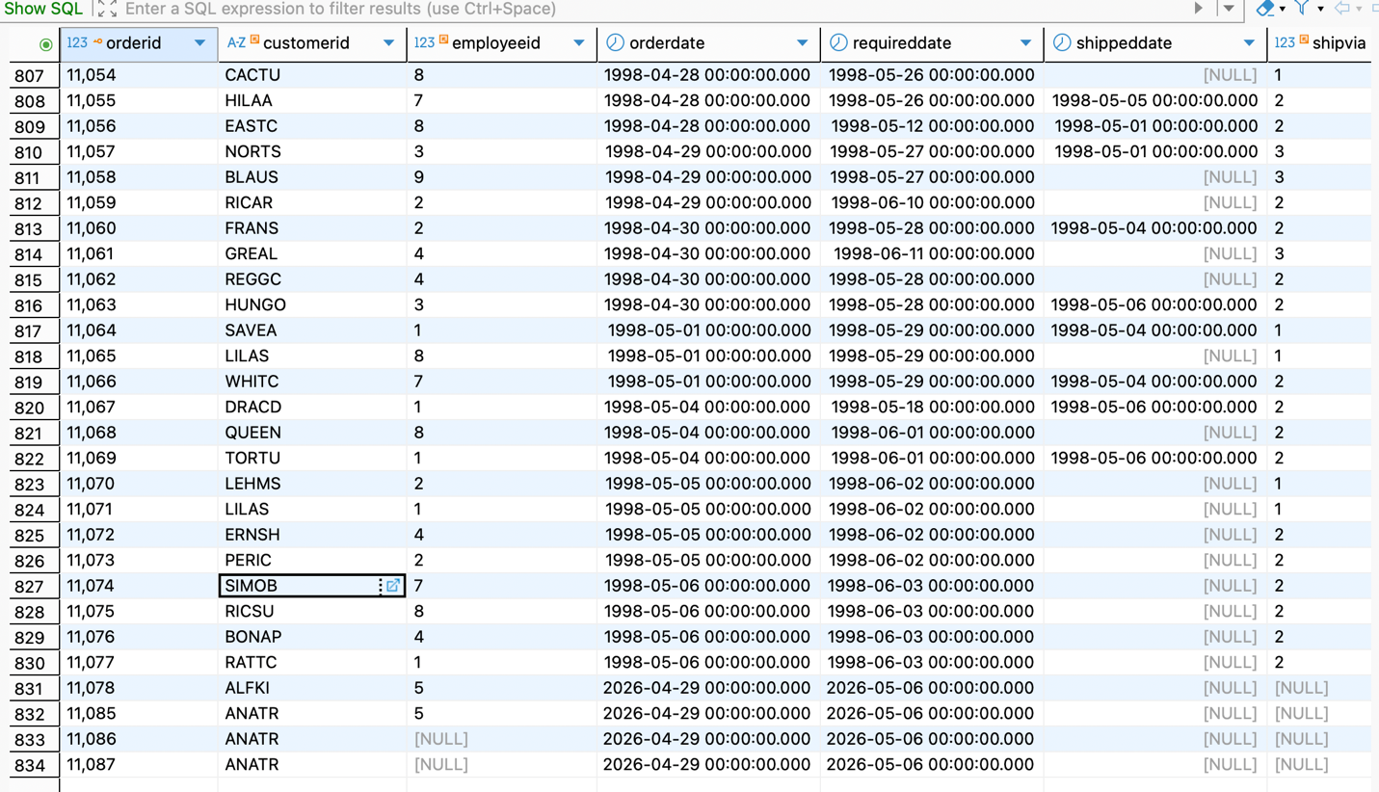

Table: order_details(before cancelling order=11087)



Table: orders(after canceling order 11087)

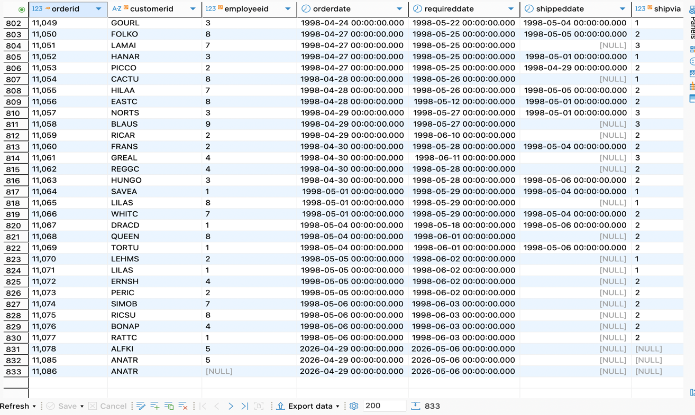

Table: order_details (after cancelling order=11087)

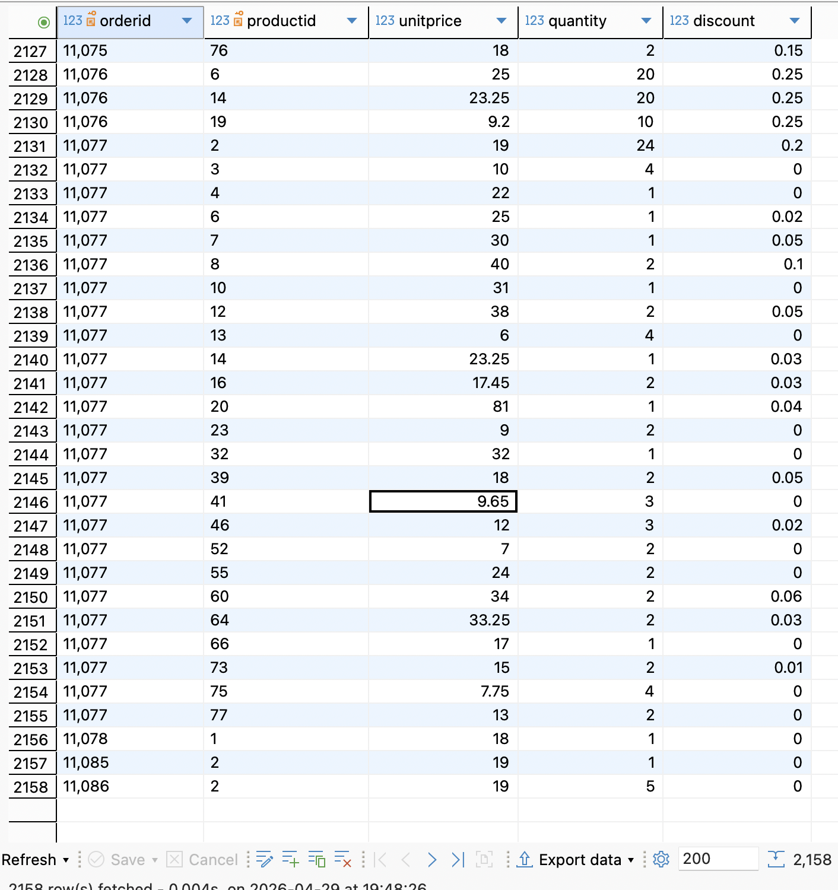

5.Create a stored procedure to transfer products from one supplier to another. If the old supplier or new supplier does not exist, rollback.

create or replace procedure transfer_products(
p_old_supplierid int,
p_new_supplierid int
)
language plpgsql
as $$
begin
if not exists (select 1 from suppliers where supplierid =p_old_supplierid) then
raise exception 'old supplier % does not exist', p_old_supplierid;
rollback;
end if;

if not exists (select 1 from suppliers where supplierid = p_new_supplierid) then
raise exception 'new supplier % not exist', p_new_supplierid;
rollback;
end if;

update products
set supplierid = p_new_supplierid
where supplierid = p_old_supplierid;

commit;

raise notice 'products transferred from supplier % to supplier %', p_old_supplierid, p_new_supplierid;
end;
$$;

call transfer_products(1, 2);
call transfer_products(2, 10);
call transfer_products(3, 6);
call transfer_products(6, 12);

outputs:

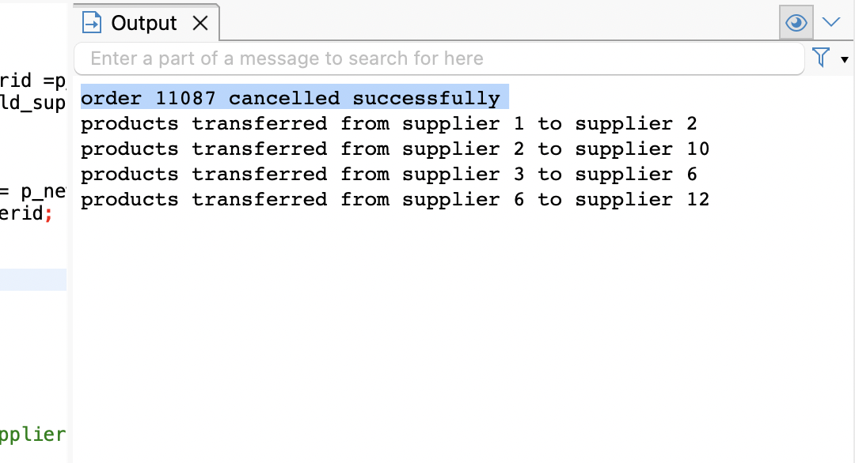

table: products (before changing suppliers)



table: products (after changing suppliers)

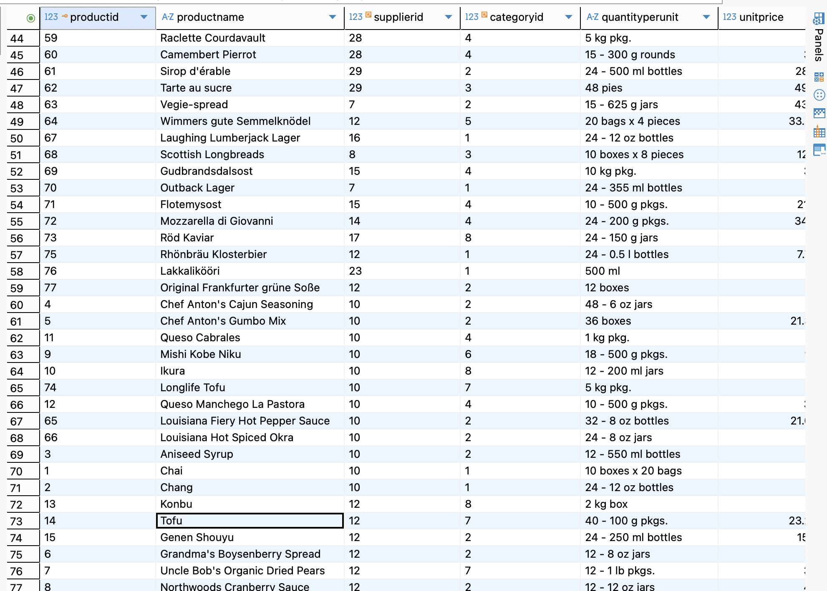

6. Create a stored procedure to update the price of all products in a category by a percentage. Rollback if the percentage is less than or equal to zero.

create or replace procedure update_category_prices(
p_categoryid int,
p_percentage decimal
)
language plpgsql
as $$
begin
if p_percentage <= 0 then
raise exception 'percentage must be greater than 0';
rollback;
end if;

if not exists (select 1 from categories where categoryid = p_categoryid ) then
raise exception 'category % does not exist', p_categoryid;
rollback;
end if;

update products
set unitprice = unitprice * (1+p_percentage / 100)
where categoryid = p_categoryid;

commit;
raise notice 'prices updated for category % by % percentage', p_categoryid, p_percentage;
end;
$$;

call update_category_prices(3, 10);
call update_category_prices(6, 12);

output:

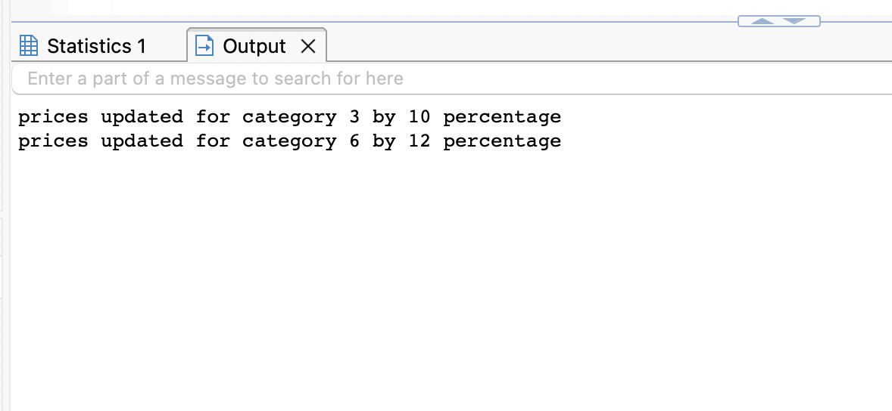

Table: products(before updating prices)

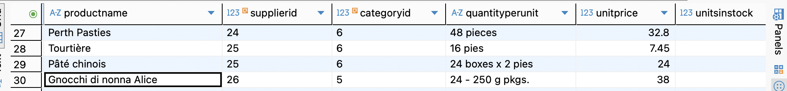

Table: products (after updating prices by given percentage)

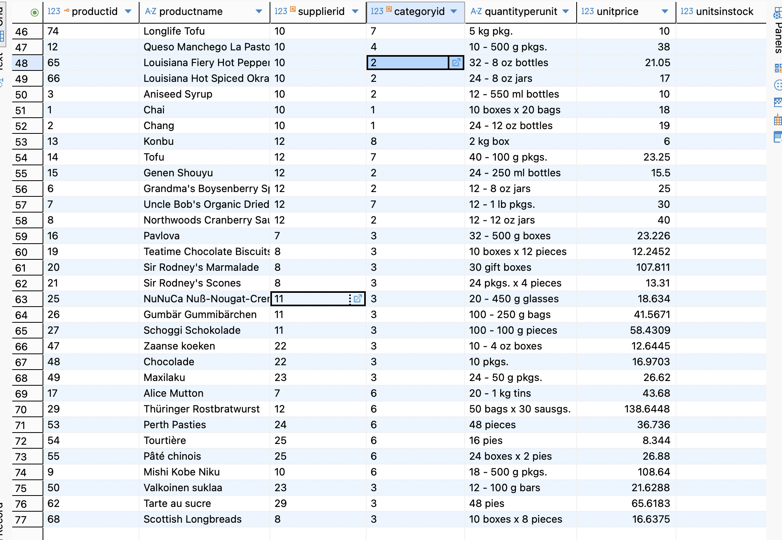

7. Create a stored procedure to add a new product under an existing category and supplier. Rollback if the category or supplier does not exist.

create or replace procedure add_new_product(
p_productname varchar(40),
p_categoryid int,
p_supplierid int,
p_unitprice decimal
)
language plpgsql
as $$
begin
if not exists (select 1 from categories where categoryid = p_categoryid) then
raise exception 'category % does not exist', p_categoryid;
rollback;
end if;

if not exists (select 1 from suppliers where supplierid = p_supplierid) then
raise exception 'supplier % does not exist', p_supplierid;
rollback;
end if;

insert into products (productname, categoryid, supplierid, unitprice)
values (p_productname, p_categoryid, p_supplierid, p_unitprice);
commit;
raise notice 'product % added successfully under category % and supplier %',
p_productname, p_categoryid, p_supplierid;
end;
$$;

call add_new_product('new product', 1, 1, 25.78);

output:

product new product added successfully under category 1 and supplier 1

Table: products with new product (productids = 78,79)

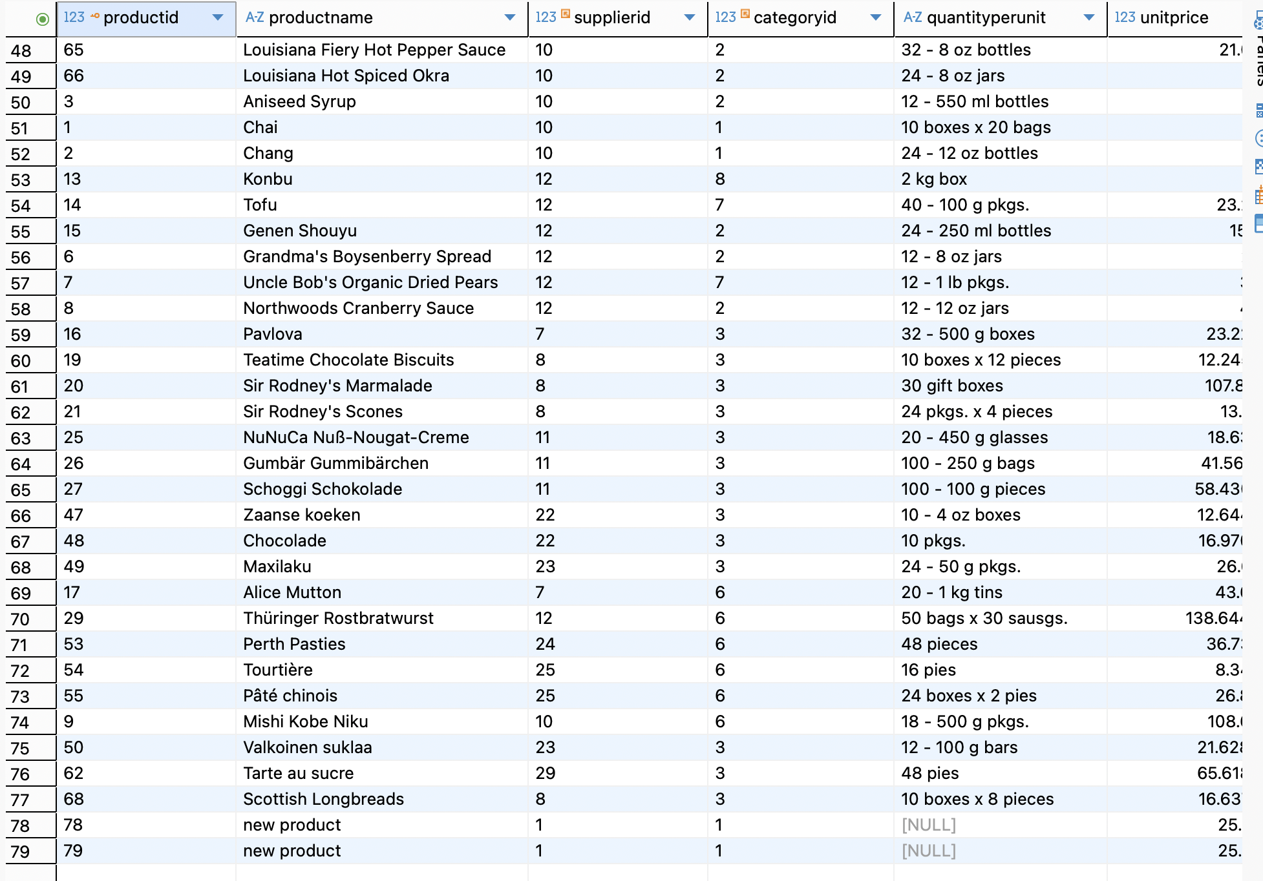

8. Create a stored procedure to delete a customer only if the customer has no orders. Use a transaction and rollback if orders exist.

create or replace procedure delete_customer(
p_customerid varchar(5)
)
language plpgsql
as $$
begin
if not exists (select 1 from customers where customerid = p_customerid) then
raise exception 'customer % does not exist', p_customerid;
rollback;
end if;

if exists (select 1 from orders where customerid = p_customerid) then
raise exception 'customer % has orders and cannot be deleted', p_customerid;
rollback;
end if;

delete from customers where customerid = p_customerid;

commit;
raise notice 'customer % deleted successfully', p_customerid;
end;
$$;

call delete_customer('AS002');
call delete_customer('PARIS');
call delete_customer('AS001');

OUTPUT:

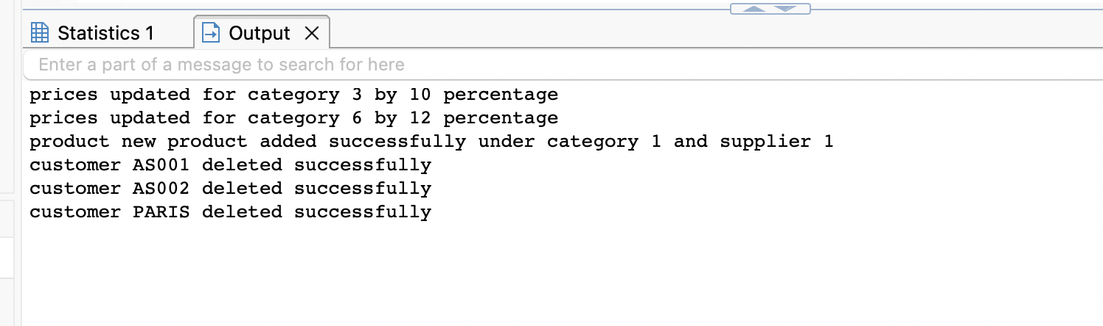

Table: customers (before deleting customers who has 0 orders)

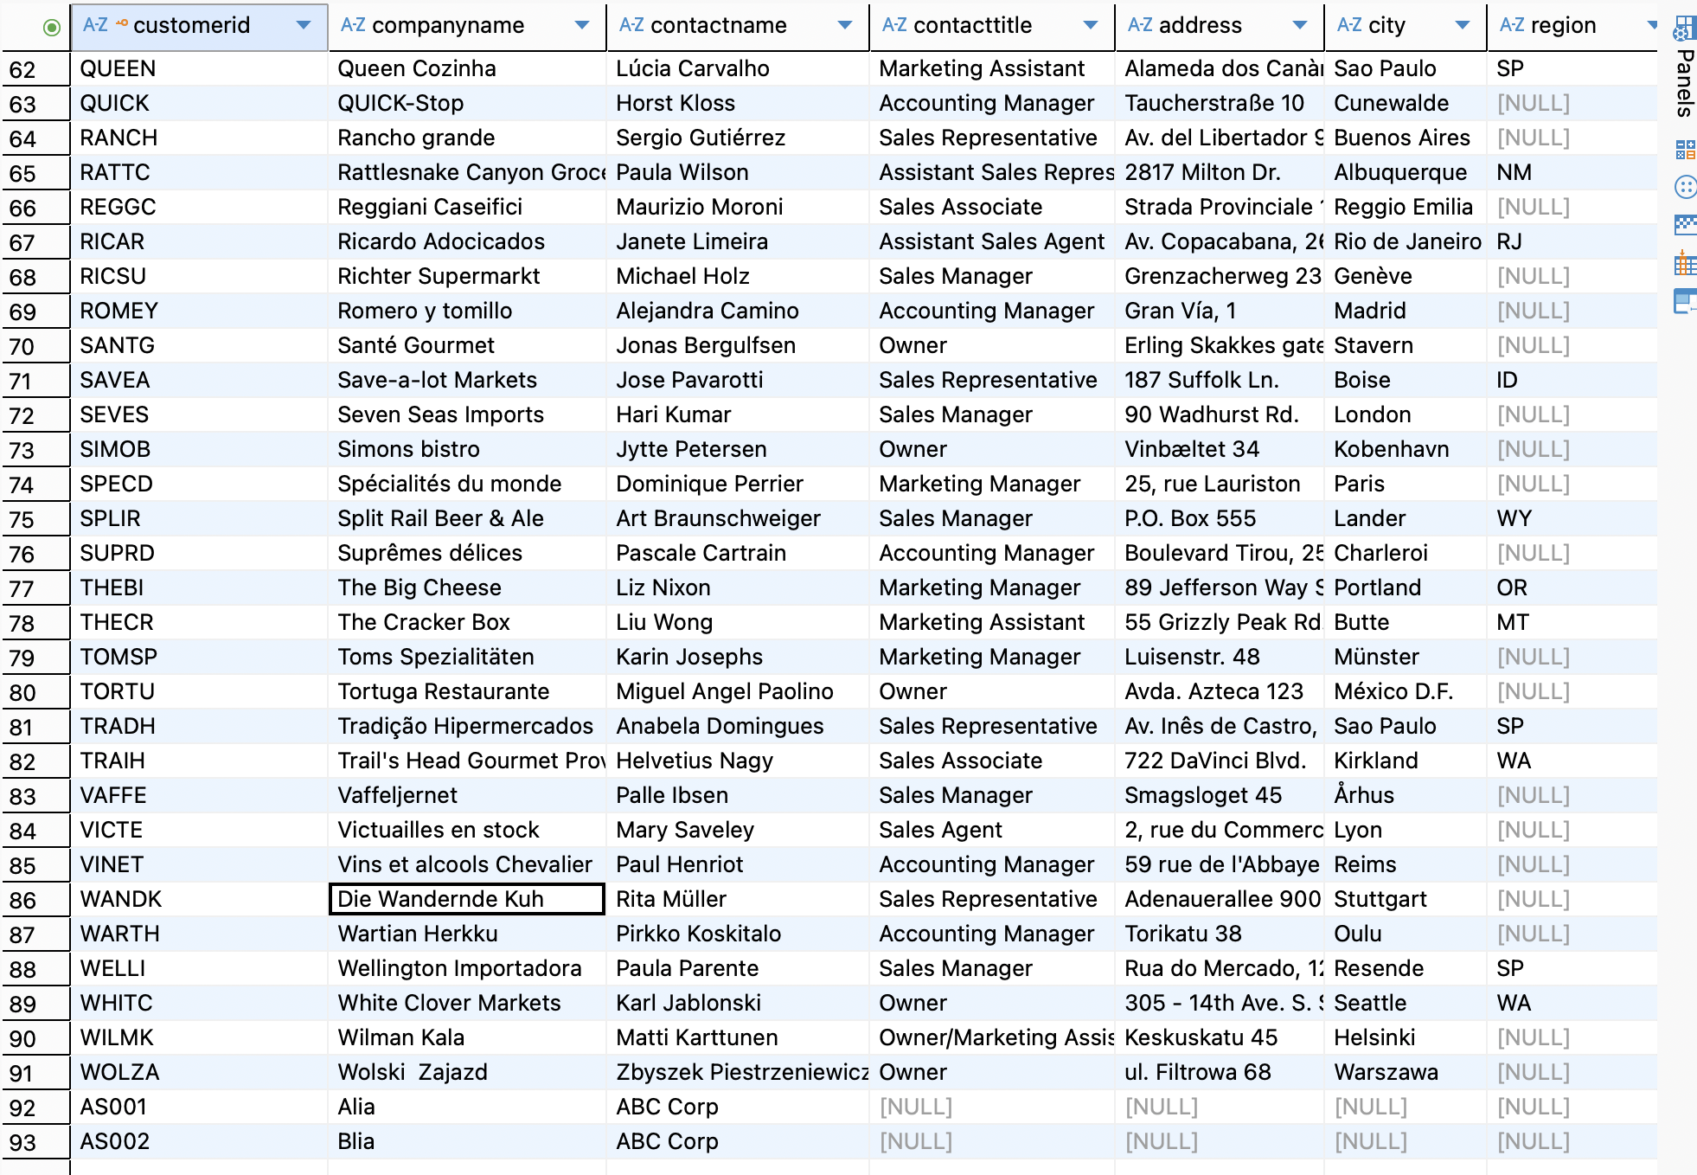

Table: customers (after deleting customers who has 0 orders)

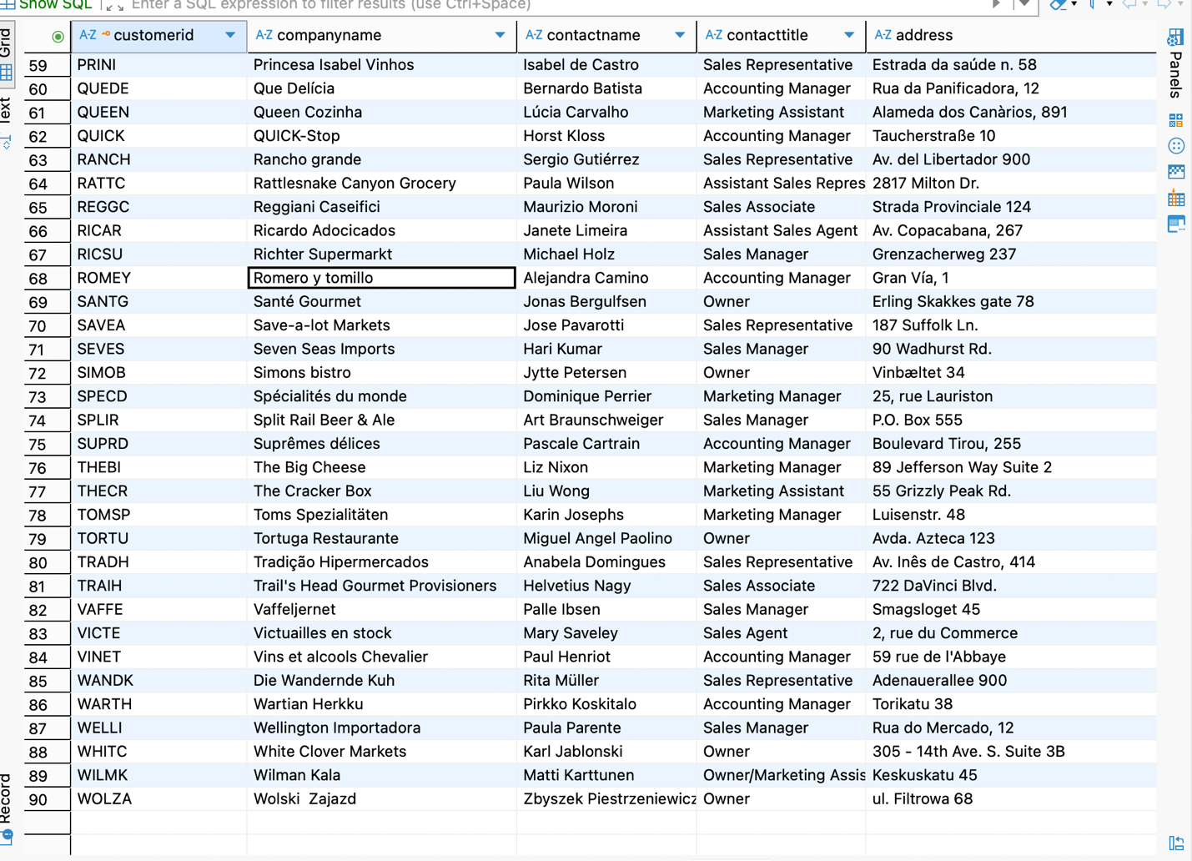

9. Create a stored procedure to apply a discount to all order details for a specific order. Rollback if the order does not exist.

create or replace procedure apply_discount(
p_orderid int,
p_discount decimal
)
language plpgsql
as $$
begin
if not exists (select 1 from orders where orderid = p_orderid) then
raise exception 'order % does not exist', p_orderid;
rollback;
end if;

if p_discount < 0 or p_discount > 1 then
raise exception 'discount must be between 0 and 1';
rollback;
end if;

update order_details
set discount = p_discount
where orderid = p_orderid;

commit;
raise notice 'discount of % applied to all products in order %', p_discount, p_orderid;

end;
$$;

call apply_discount(10250, 0.10);

output:

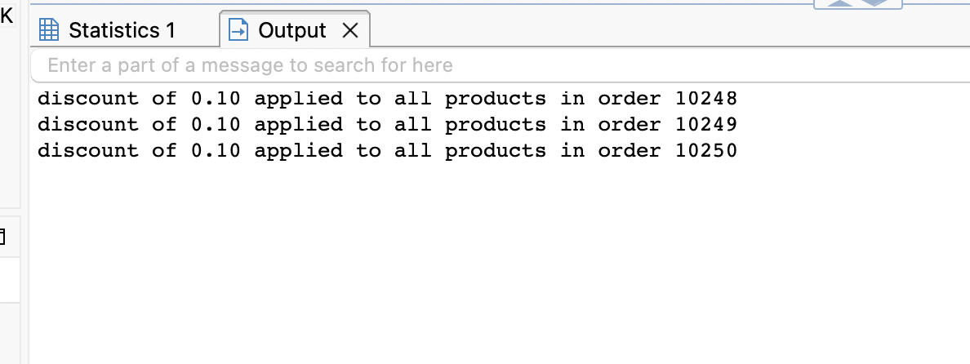

Table: order details(before applying discount for products on ordered=10248 10249)

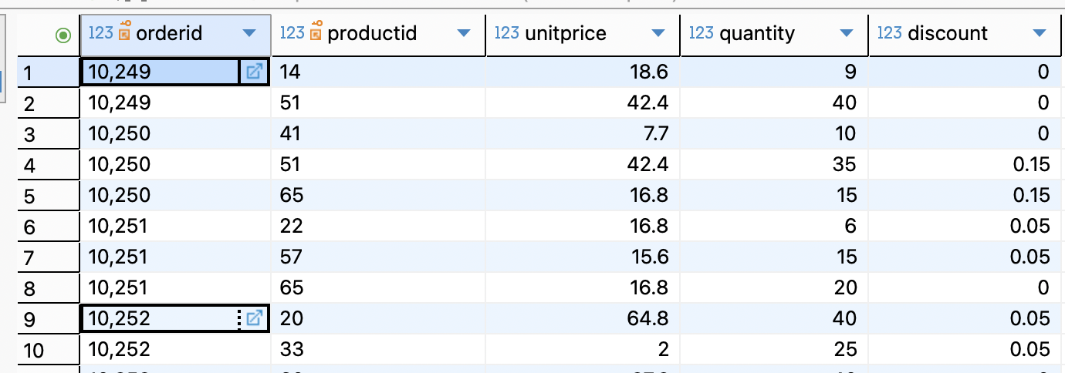

Table: order details(after applying discount for products on ordered=10248)

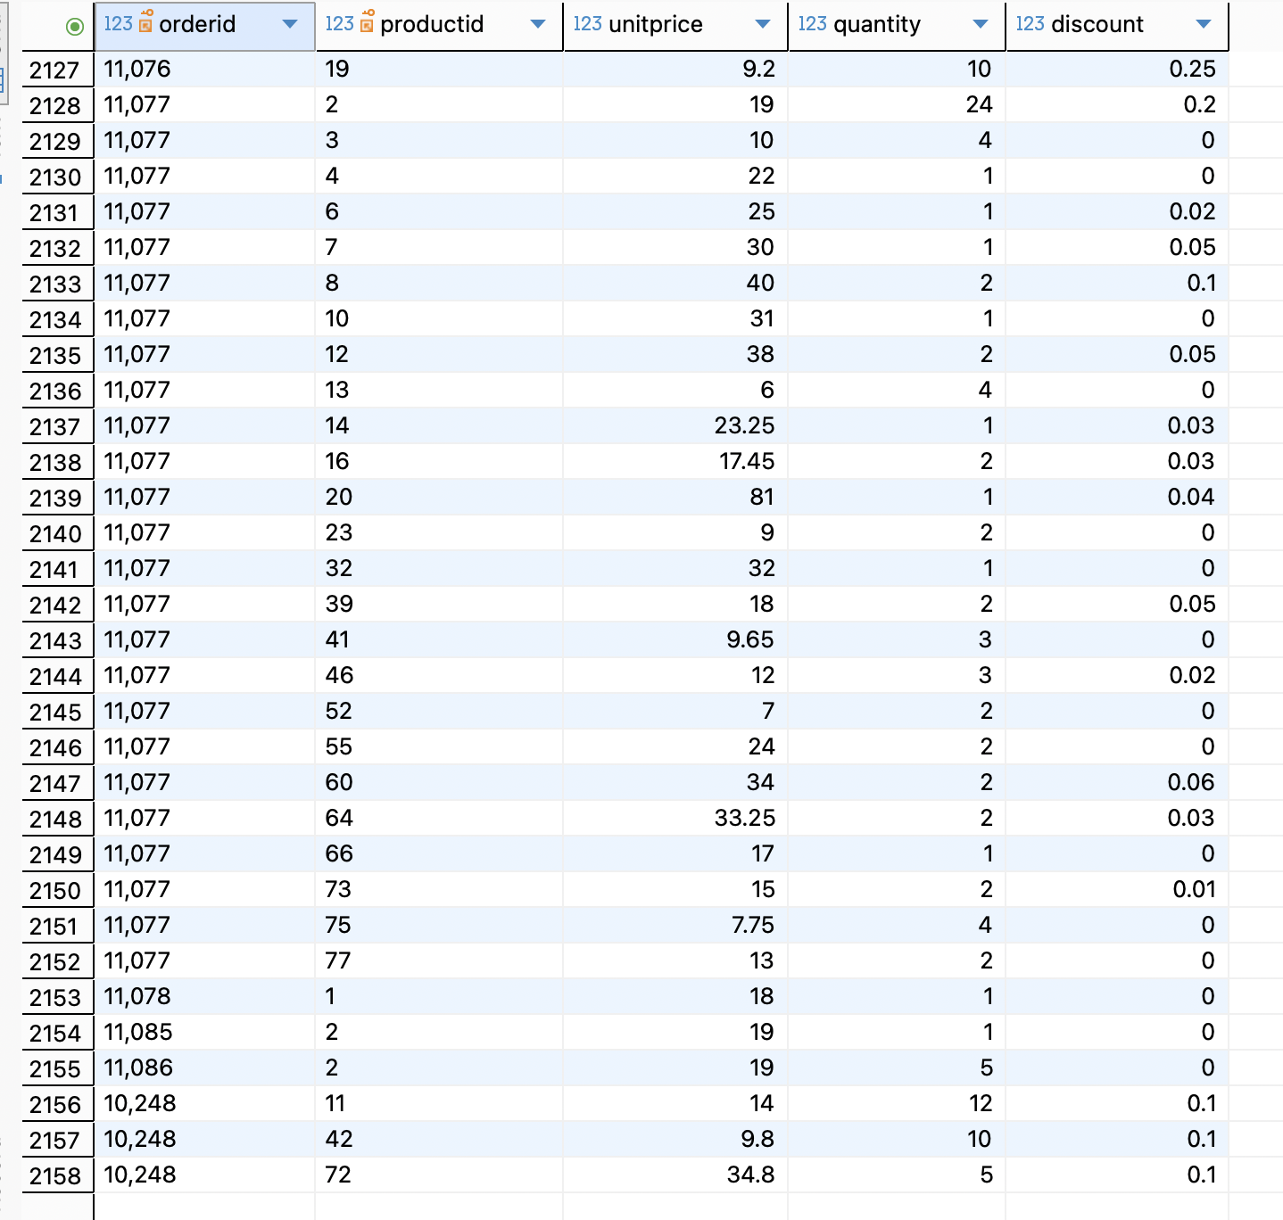

10. Create a stored procedure to place an order with multiple products. Insert the order and all order items in one transaction. If any product is invalid or stock is insufficient, rollback the complete order.

create or replace procedure place_multiple_order(
p_customerid varchar(5),
p_employeeid int,
p_products jsonb
)
language plpgsql
as $$
declare
v_orderid int;
v_product record;
v_unitprice decimal;
v_product_count int;
begin
if not exists (select 1 from customers where customerid = p_customerid) then
raise exception 'customer % does not exist', p_customerid;
end if;

insert into orders (customerid, employeeid, orderdate)
values (p_customerid, p_employeeid, current_date)
returning orderid into v_orderid;

v_product_count := 0;

for v_product in
select * from jsonb_to_recordset(p_products) as x(productid int, quantity int)
loop
select unitprice into v_unitprice
from products
where productid = v_product.productid;

if not found then
raise exception 'product % does not exist', v_product.productid;
end if;

if (select unitsinstock from products where productid = v_product.productid) < v_product.quantity then
raise exception 'insufficient stock for product %', v_product.productid;
end if;

insert into order_details(orderid, productid, unitprice, quantity)
values (v_orderid, v_product.productid, v_unitprice, v_product.quantity);

update products
set unitsinstock = unitsinstock - v_product.quantity
where productid = v_product.productid;

v_product_count := v_product_count + 1;
end loop;

commit;
raise notice 'order % placed successfully with % products', v_orderid, v_product_count;

end;
$$;

call place_multiple_order('ANATR', 2, '[{"productid": 18, "quantity": 5}, {"productid": 22, "quantity": 5}]'::jsonb);

output:
order 11091 placed successfully with 2 products

Table: products before placing orders on product ids 18 and 22 stocks are 42 and 104
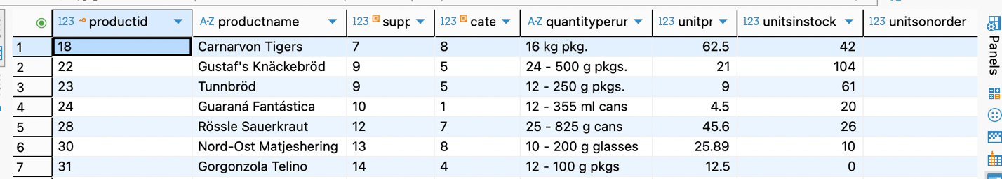

Table: order_details

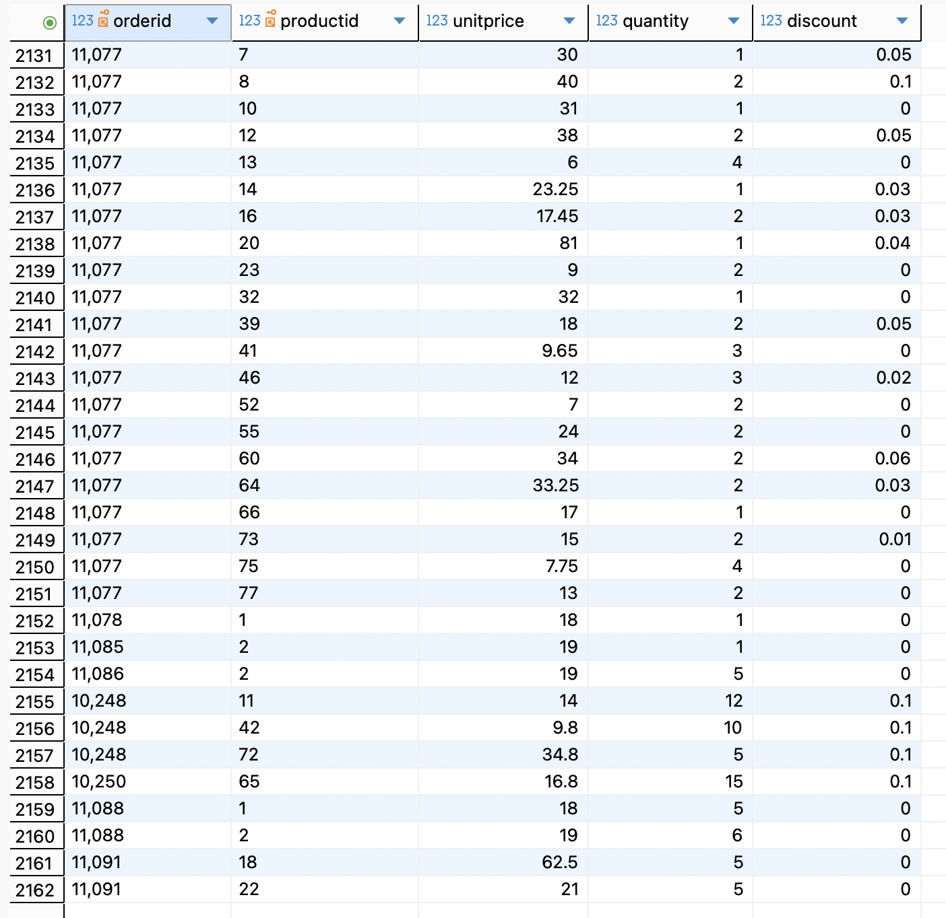

Table: products with stock updation after placing orders on product ids 18 and 22, stocks are 37 and 99.

